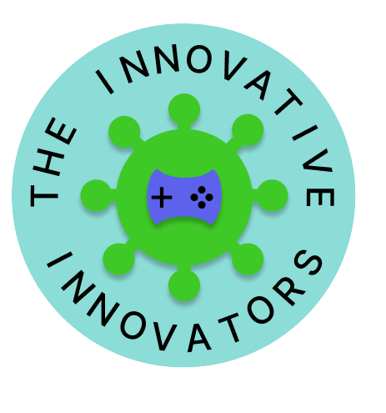

**Table of Contents**

**1.** **INFORMATION ABOUT THE TEAM** 3

**2.** **OUR GAME** 3

**3.** **STAGES OF REALIZATION** 3

**4.** **USED TECHNOLOGIES** 3

**5.** **TEAM LOGO** 4

# **INFORMATION ABOUT THE TEAM**

|  |  |  |
| --- | --- | --- |
| **NAME** | **CLASS** | **ROLE** |
| **Iva Nedkova** | 9 B | Scrum trainer |
| **Todor Ivanov** | 9 G | Back-end developer |
| **Bozhidar Dukov** | 9 V | Back-end developer |
| **Daniel Stefanov** | 9A | Designer |

# **OUR GAME**

The purpose of our game is to create an educational game

# **STAGES OF REALIZATION**

* We chose the name of the team
* We assigned roles
* We created the logo
* We made the README.md file
* We wrote the code for the game
* We created the presentation and the documentation

# **USED TECHNOLOGIES**

* **C and C++** - for creating the game
* **GitHub** - for project synchronization
* **Git** -to commit our changes
* **Visual Studio** - for writing the code
* **Power Point** - for creating the presentation
* **Word** - for creating the documentation
* **Excel** - for creating the QA documentation
* **Figma** - for creating the logo
* **Piskel** – for creating the buttons

# **TEAM LOGO**

